Higher Education
Name.
Institution.
Date.

Higher Education
Number 1: Role of the Faculty Senate or Council
The faculty senate plays a vital role in promoting the success of the university. Ben Trachtenberg was a council member in the University of Mississippi and also chaired the senate for three years. He explains that the senate provides an opportunity for diverse ideas to be applied in developing policies that guide academics in the country. According to him, the faculty senate in the university was effective and advocated for the rights of members to be included in most decision making. The members were included in planning for events such as student orientation to provide educational guidance. Also, the council helped in advocating for the rights of members to have freedom in using the institution's educational facilities (Trachtenberg, 2018).
Trachtenberg (2018) asserts that the faculty senate involved members in discussing curriculum changes to provide quality instruction to students. However, he also affirms that these decisions had to pass through the senate body for approval. Additionally, the university president has a right to overrule these decisions if he has a good reason. Trachtenberg (2018) adds that the chair influenced the success of the faculty senate. The leader has the responsibility to ensure there is effective communication to motivate members to work towards achieving the university’s goal. Also, he or she should develop trust to ensure that confidential information is not leaked without approval.
Number 3: Assessment Plan for Administrative Units
An administrative assessment plan is vital in determining the effectiveness of strategies set to promote learning in the institution (Lombardi, 2013). The plan enables leaders to evaluate the operations and identify areas that require changes. Also, the plan includes specific indicators to analyze the performance. Additionally, organizations that utilize this plan ensure that there is continuous data collection to improve processes in the institution. Besides, an external audit can be involved to monitor the effectiveness of various units. The following is an example of an assessment plan of administrative units in Agnes Scott College:
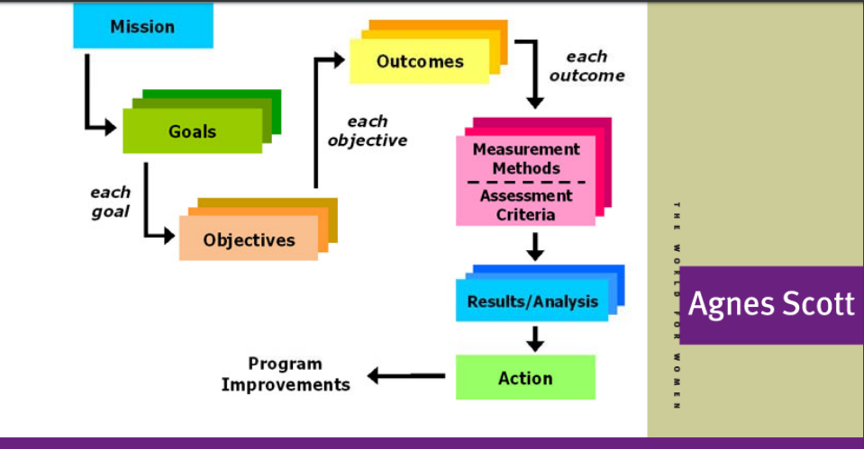
Agnes Scott College uses this plan to evaluate the support services and ensure each unit is meeting its expected outcomes. Hence, each department is expected to produce quality services. The institution considers specific parts of the plan as necessary, and these include; the mission, goals, objectives, outcomes, measurement methods, results, action, and program improvements (McGuire, 2019).
Regarding the mission, the institution affirms that each unit should align its operation to achieve the institution's goals. Also, it is necessary to evaluate the specific goals set in the institution. Some of these goals include; educating the faculty and students on how to apply technology and to ensure the account department produces transcripts effectively. Also, the objectives include; to ensure safety in the campus, to ensure students can utilize library services and that students are satisfied with the registration proves. Additionally, the outcomes are based on producing graduates who can be absorbed in the job market. Hence, students should be able to produce acceptable resumes. The method used to measure this outcome includes the use of surveys. After the results are analyzed, the institution develops changes that need to be made. For instance, a faculty may recommend changes in the teaching skills. This action is discussed and implemented after approval (McGuire, 2019).
I would rate the plan as a 9. The plan meets the standards required to assess the operations of academic units in the campus. Also, the goals are specific and can be measured to identify best practices and needs. As a result, it is easy to develop strategies to ensure quality services are provided to students. Additionally, different members are involved in this plan to ensure that all sectors that deal with students’ performance are evaluated.
Number 4: Nichols’ Model
Nichols' model involves five steps that are used to assess whether the university’s strategies promote student learning. Hence, this method helps in developing specific improvements to fill the loops. The following is a sample of the application of the model for assessment of one of a university’s goal.

Column 1: | Column 2: | Column 3: | Column 4: | Column 5:
Goal | Intended Outcome | Methods used for Analysis | Summary of Data | Use of Results
To train students on new technologies and prepare them for the digital market. | 90% of Information Technology graduates should agree that the techniques taught in the degree program are up-to-date with the technology applied in the field | Survey questions used to get the students' opinions. | 85% of graduates affirm that the techniques taught are updated regarding current advancements. | The curriculum will be revised, and faculty members to be trained on the use of modern technology.

Discussion
Article Review: Implications of Higher Education
Higher education leaders face challenges, especially due to current changes in the competitive market. The article on Admission Directors Face Growing Pressure by Scott Jaschik elaborates on some of these challenges. Jaschik (2019) affirms that the admission director have various concerns that affect their ability to meet admission deadlines. Some of these concerns relate to race and ethnicity, SAT or ACT requirements, debt worries, and bribery.
Moreover, Jeschik (2019) asserts that private institutions are more likely to consider factors such as gender and race of students before admission. Besides, issues regarding bribery affect fairness in the admission system. However, only 42% of institutions have adopted measures to solve this issue. Hence, these statistics create an alarm on the effectiveness of the institutions to focus on providing quality services as opposed to earning profits.
James Simon, on the article on Three Major Categories Change Colleges will have to deal with in the Coming Decades, discusses issues regarding the quality of education required in different decades. Simon (2019) asserts that leaders in higher education should consider expected changes in access and affordability of the educational population among people. The expected decline in admission will affect aspects such as talents in universities. Hence, these institutions should develop programs to encourage students, especially those from lower-income backgrounds, to enroll in colleges. Besides, these students should also be provided with quality services, including research, internships, abroad studies, and community engagement. As a result, these opportunities will enable students to become more prepared to join professionals that have unknown predicted demands. Also, graduates should be encouraged to acquire more knowledge continuously due to changing needs in the market (Simon, 2019).
Article Review: Admin 101 – How to Manage Strategic Planning Process
Retrieved from https://www.chronicle.com/article/Admin-101-How-to-Manage-the/247126
The article on How to Manage Strategic Planning Process by David D. Perlmutter (2019) highlights primary factors that should be considered when developing an effective strategic plan. First, Perlmutter (2019) affirms that the plan should be managed by one leader who should only focus on this task. Second, the article asserts that long committees can be challenging and may prolong the planning and implementation process. Hence, the leader should ensure the members involved should feel empowered to balance efficiency and democracy (Perlmutter, 2019).
Third, Permutter (2019) advises workflow administrators to develop strict and specific priorities. Also, the proposed changes should be able to solve the fundamental problems experienced in the institution. Besides, each member should be guided on how to work towards accomplishing these strategies.
Bonus: Reflection and Practice: Organization Chart
Chief Financial Officer
Executive Deans
Vice President in charge of Investment
Human Resource
Chief Operating officer
Provost
President

Board of Trustees

Conclusion
To sum up, the role of the faculty senate is essential in ensuring academic affairs are implemented and managed effectively. Hence, the chair should ensure that members feel empowered and encouraged to participate in the development of policies that guide operations in the institution. Also, delegated duties should be specified to avoid confusion. Additionally, an assessment plan is essential in higher education to evaluate strategies and ensure proposed changes are effective. This approach also enables administrators to assess whether or not students receive quality education to prepare them for the changing demands in diverse professions. Furthermore, higher education leaders are challenged to ensure they enroll students from different ethnic and racial groups and balance both genders. Besides, enrolled students should be provided with skills and knowledge that enable them to perform in their desired careers (Lombardi, 2013).

References
Jaschik, S. (2019).Admission Directors Face Growing Pressure. Inside Higher ED. Retrieved from: https://www.insidehighered.com/news/survey/admissions-directors-face-growing-pressure
Lombardi, V. (2013). How Universities Work. Baltimore: Johns Hopkins University Press.
McGuire, K. (2019). Assessment for Administrative Units.Agnes Scott College.
Perlmutter, D. (2019). Admin 101: How to Manage the Strategic – Planning Process.
Simon, J. (2019). Three Major Categories Change Colleges will have to deal with in the Coming Decades. Inside Higher ED. Retrieved from: https://www.insidehighered.com/views/2019/09/24/three-major-categories-change-colleges-will-have-deal-coming-decades-opinion
Trachtenberg, B. (2018). Advice for a New Faculty Senate Chair.American Association of University Professors. Retrieved from: https://www.aaup.org/article/advice-new-faculty-senate-chair#.XZY8m0Yza01

